**POWER BI ASSIGNMENT-15**

**Topic** – Overview of Maps.

**Exercise** – Create a maps showing passenger numbers of UK stations, with drilldown.

Q1. Create a map showing the usage of stations for the region and passenger number chosen in the slicers

Step -1. Insert a map visual and pull relevant columns into fields as per curriculum as shown below. After visual level filter as per requirement as shown below.

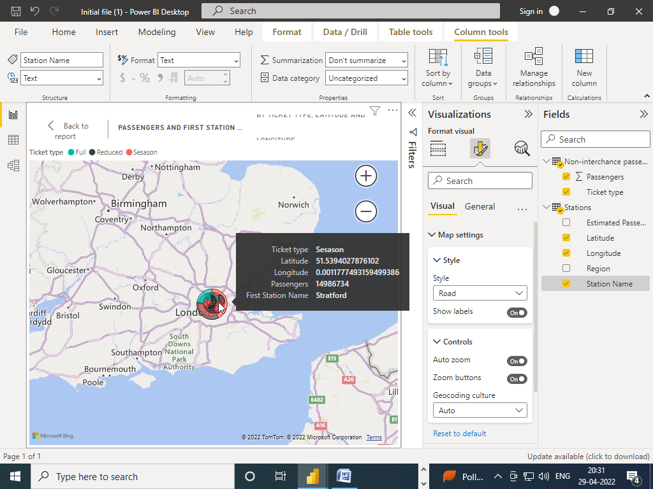

Q2. Add a table which shows the data for the pie chart slices you select

Step-2. Creating a table visual and applying filter as per requirement

